Daniel Meyer

CSE 420-01

Lab 6

Vectors and Subdivision

**Lab 6 Report**

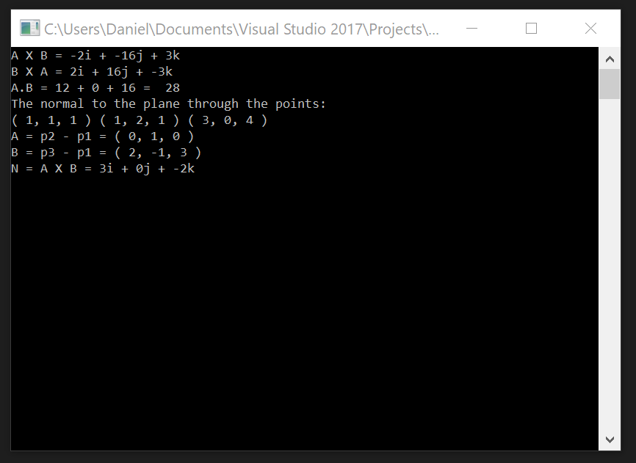

**Extra Credit #1 (Success):**

#include <iostream>

using namespace std;

void dotProduct(int a[], int b[])

{

cout << "A.B = ";

//cout << "(Ax * Bx) + (Ay * By) + (Az * Bz) = " << endl;

cout << (a[0] * b[0]) << " + " << (a[1] * b[1]) << " + " << (a[2] * b[2]) << " = ";

cout << " " << (a[0] * b[0]) + (a[1] * b[1]) + (a[2] * b[2]) << endl;

}

void crossProduct(int a[], int b[])

{

cout << "A X B = ";

cout << (a[1] * b[2] - a[2] * b[1]) << "i + " << (a[2] * b[0] - a[0] * b[2]) << "j + " << (a[0] * b[1] - a[1] * b[0]) << "k" << endl;

cout << "B X A = ";

cout << (b[1] * a[2] - b[2] * a[1]) << "i + " << (b[2] * a[0] - b[0] * a[2]) << "j + " << (b[0] * a[1] - b[1] * a[0]) << "k" << endl;

}

void findNormal(int p1[], int p2[], int p3[])

{

cout << "The normal to the plane through the points: " << endl;

cout << "( " << p1[0] << ", " << p1[1] << ", " << p1[2] << " ) ";

cout << "( " << p2[0] << ", " << p2[1] << ", " << p2[2] << " ) ";

cout << "( " << p3[0] << ", " << p3[1] << ", " << p3[2] << " ) " << endl;

cout << "A = p2 - p1 = ( " << (p2[0] - p1[0]) << ", " << (p2[1] - p1[1]) << ", " << (p2[2] - p1[2]) << " )" << endl;

int a[3] = { p2[0] - p1[0], p2[1] - p1[1], p2[2] - p1[2] };

cout << "B = p3 - p1 = ( " << (p3[0] - p1[0]) << ", " << (p3[1] - p1[1]) << ", " << (p3[2] - p1[2]) << " )" << endl;

int b[3] = { p3[0] - p1[0], p3[1] - p1[1], p3[2] - p1[2] };

cout << "N = A X B = ";

cout << (a[1] * b[2] - a[2] * b[1]) << "i + " << (a[2] * b[0] - a[0] * b[2]) << "j + " << (a[0] * b[1] - a[1] * b[0]) << "k" << endl;

}

int main()

{

int a[3] = { 3, 0, 2 };

int b[3] = { 4, 1, 8 };

int p1[3] = { 1, 1, 1 };

int p2[3] = { 1, 2, 1 };

int p3[3] = { 3, 0, 4 };

crossProduct(a, b);

dotProduct(a, b);

findNormal(p1, p2, p3);

return 0;

}

**Extra Credit #2 (Success):**

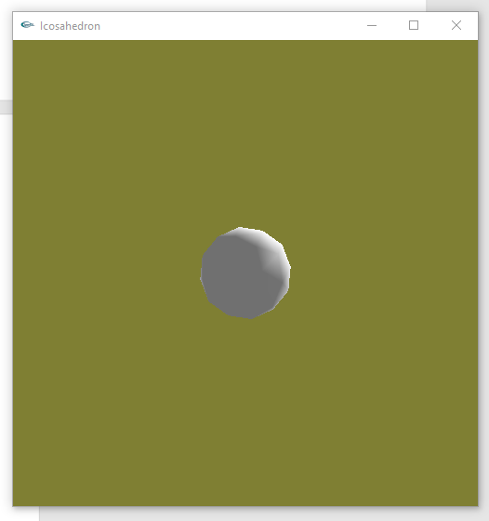

80-sided die

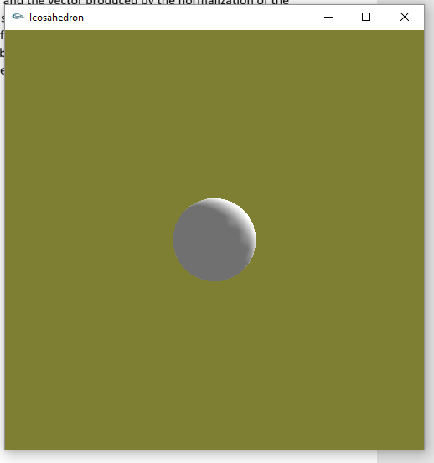

320-sided die

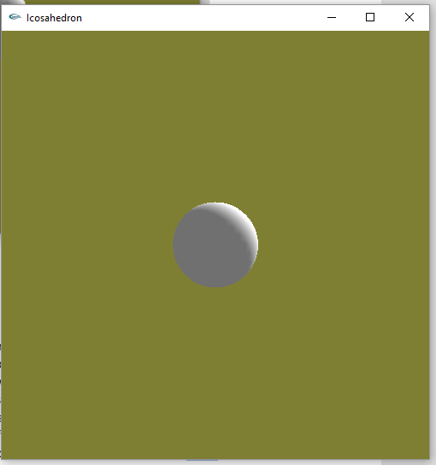

1280-sided die

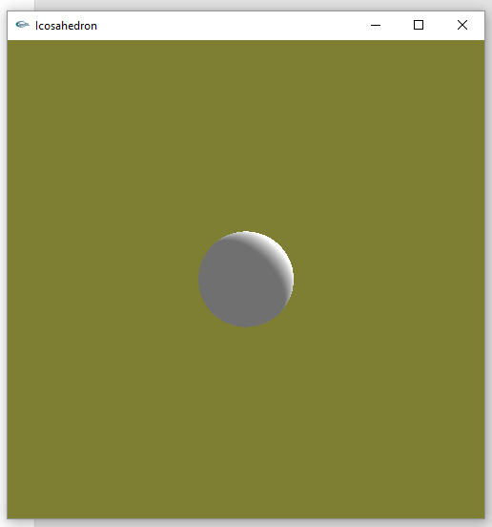

5120-sided die

void performSub()

{

for (int i = 0; i < 20; i++) {

subdivide(&vdata[tindices[i][0]][0],

&vdata[tindices[i][1]][0],

&vdata[tindices[i][2]][0], numSub);

}

}

void display(void)

{

glMatrixMode(GL_MODELVIEW); // position and aim the camera

glLoadIdentity();

gluLookAt(8.0, 8.0, 8.0, 0.0, 0.0, 0.0, 0.0, 1.0, 0.0);

glClear(GL_COLOR_BUFFER_BIT | GL_DEPTH_BUFFER_BIT);

glColor3f(1, 0, 0); //This would have no effect

glEnable(GL_CULL_FACE);

glCullFace(GL_BACK);

glRotatef(ay, 0, 1, 0);

if (translate)

glTranslatef(5, 0, 0);

performSub();

glFlush();

}

void keyboard(unsigned char key, int mousex, int mousey)

{

switch (key) {

case 27: // escape

exit(-1);

case 't':

if (translate)

translate = false;

else

translate = true;

break;

case 's':

if (numSub == 4)

numSub = 1;

else

numSub++;

}

glutPostRedisplay();

}

**Summary:**

For this assignment I created a program that calculated the dot product and cross product of two vectors as well as the normal vector to the plane that passes through the given three points. I wrote this program to both show the work for calculating the value of the dot product, the vector produced by the cross product and the vector produced by the normalization of the three points. The program also serves to satisfy the extra credit points of using a program to show the work. The results produced in the program also match the work I had done by hand on a piece of paper. I also modified the program we used in class to create an 80- and 320- sided die using subdivision to use a keyboard input and increase the “depth” of the subdivision to create a 1280- and 5120-sided die. The more triangles we add to the die the smoother and closer to a perfect sphere the die becomes. The programs ran successfully and without errors. As a result, I believe I deserve the full 20 points and the extra 15 point extra credit for the assignment.